Chinook PlayList.

# ERD for UI/UX process



The playlists will contain purchased tracks and non-purchased tracks. Only tracks that have been purchased would play (this is functionality of another subsystem).

The manage playlist OLTP sample will not include generation of Invoices for playlists. This would be another button (Purchase) on the Possible UI/UX Interface.

When creating your prototype, you can expect some changes as you create your system and review it with the client. A prototype is a starting point.

# Possible UX Interface

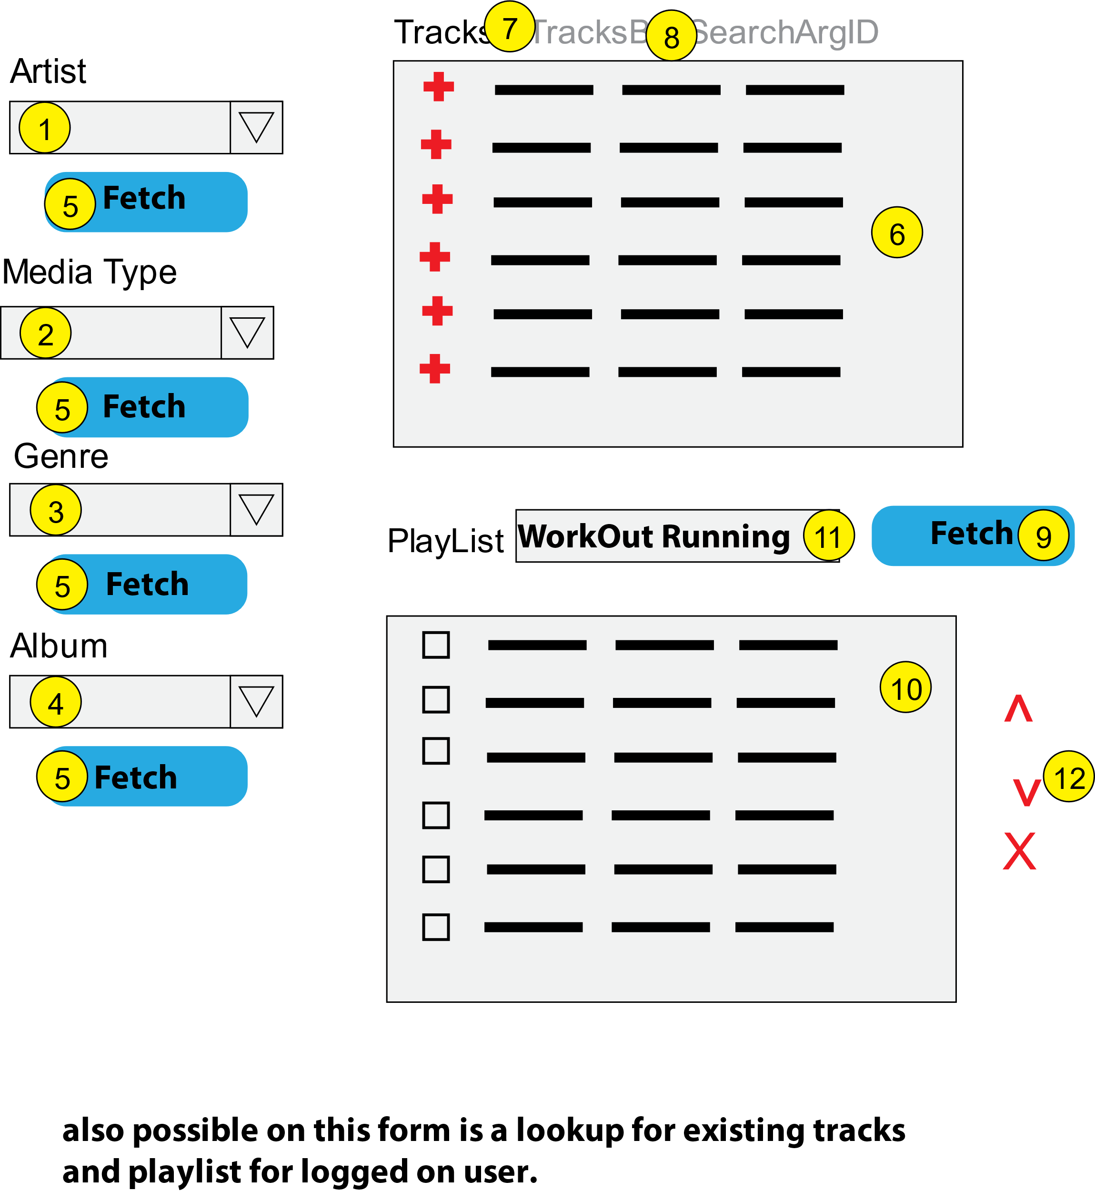

|  |  |  |
| --- | --- | --- |
| **Controls** | | **Events** |
| ArtistDDL (**1**) | | None / wired via ObjectDataSource |
| **BBL Class(es) and Method (s)** | | |
| ArtistController | List<SelectionList> List_ArtistNames()  Retrieve a list of artist names and artist id for DDL | |
| **SQL Table(s): (C,R,U,D)** | | **Entities/DTOs/POCOs** |
| Artists (R) | | SelectionList (P) |

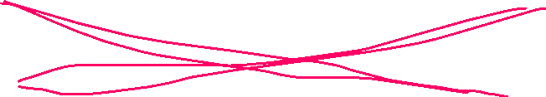

|  |  |  |
| --- | --- | --- |
| **Controls** | | **Events** |
| MediaTypeDDL (**2**) | | None / wired via ObjectDataSource |
| **BBL Class(es) and Method (s)** | | |
| MediaTypeController | List<SelectionList> List_MediaTypeNames()  Retrieve a list of media type names and media type id for DDL | |
| **SQL Table(s): (C,R,U,D)** | | **Entities/DTOs/POCOs** |
| MediaTypes (R) | | SelectionList (P) |

|  |  |  |
| --- | --- | --- |
| **Controls** | | **Events** |
| GenreDDL (**3**) | | None / wired via ObjectDataSource |
| **BBL Class(es) and Method (s)** | | |
| GenreController | List<SelectionList> List_GenreNames()  Retrieve a list of genre names and genre id for DDL | |
| **SQL Table(s): (C,R,U,D)** | | **Entities/DTOs/POCOs** |
| Genres (R) | | SelectionList (P) |

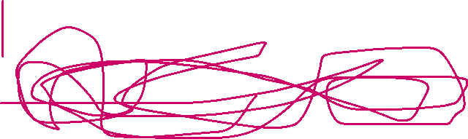

|  |  |  |
| --- | --- | --- |
| **Controls** | | **Events** |
| AlbumDDL (**4**) | | None / wired via ObjectDataSource |
| **BBL Class(es) and Method (s)** | | |
| AlbumController | List<SelectionList> List_AlbumTitles()  Retrieve a list of album titles and album id for DDL | |
| **SQL Table(s): (C,R,U,D)** | | **Entities/DTOs/POCOs** |
| Albums (R) | | SelectionList (P) |



|  |  |  |
| --- | --- | --- |
| **Controls** | | **Events** |
| Fetch (Artist, MediaType, Genre, Album) (**5**),  Tracks (**6**), TracksBy (**7**), SearchArgID (**8**) | | OnClick / wired via ObjectDataSource   * Move selection value to TracksBy which identifies DDL picked, (hidden field) * DDL id to SearchArgID; (hidden field)  * Bind data to Tracks   (each button will have its own physical event methods) |
| **BBL Class(es) and Method (s)** | | |
| TracksController | List<TrackList> List_TracksForPlaylistSelection(string tracksby, string arg)  Retrieve a list of tracks for supplied selection type and argument strings. Return trackid, song, title, artist, media, genre, composer, timelength, size, unitprice. Display in Tracks. | |
| **SQL Table(s): (C,R,U,D)** | | **Entities/DTOs/POCOs** |
| Tracks (R) | | TrackList (P) |

|  |  |  |
| --- | --- | --- |
| **Controls** | | **Events** |
| Fetch (**9**), Playlist (**10**), PlayListName (**11**) | | Fetch OnClick   * Validate data present; * call BLL; * Bind returned data to PlayList. |
| **BBL Class(es) and Method (s)** | | |
| PlaylistTracksController | List< UserPlaylistTrack > List_TracksForPlaylist(string playlistname, string username)  Retrieve a list of tracks for supplied playlist name and username. Return trackid, title, timelength, unitprice, tracknumber. Display in PlayList. | |
| **SQL Table(s): (C,R,U,D)** | | **Entities/DTOs/POCOs** |
| PlayList (R), PlaylistTracks(R) | | UserPlaylistTrack (P) |

|  |  |  |
| --- | --- | --- |
| **Controls** | | **Events** |
| Tracks: Plus Sign (**6**), PlayListName (**11**),PlayList(10)(this will be filled from event of finding a playlist) | | OnCommand   * Collect track information (trackid) and playlist name and validate;  * send to BLL for adding track to playlist; * refresh playlist. |
| **BBL Class(es) and Method (s)** | | |
| PlaylistTracksController | void Add_TrackToPlaylist(string playlistname, string username, int trackid)  TRX   * create playlist if needed, set tracknumber to 1,  * playlist exists, find current highest tracknumber to increment by 1 * verify desired track not already on list, if so reject * add new track to playlist tracks | |
| **SQL Table(s): (C,R,U,D)** | | **Entities/DTOs/POCOs** |
| PlayList(C opt), PlaylistTracks(C) | |  |

|  |  |  |
| --- | --- | --- |
| **Controls** | | **Events** |
| Up/Down (**12**), PlayListName (**11**), PlayList (**10**) | | OnCLick   * Collect track id, track number, playlist name and validate (only 1 track can move); * send to BLL for moving track in playlist; * refresh playlist. |
| **BBL Class(es) and Method (s)** | | |
| PlaylistTracksController | void Move_TrackInPlaylist(string playlistname, string username, int trackid, int tracknumber, string direction)  TRX(determine if move necessary, swap tracks depending on direction)   * if already a top and moving up, reject move * if already a bottom and moving down, reject move * move up, swap with track above by altering tracknumbers * move down, swap with track below by altering tracknumbers. | |
| **SQL Table(s): (C,R,U,D)** | | **Entities/DTOs/POCOs** |
| Playlist(R), PlaylistTracks(U) | |  |

|  |  |  |
| --- | --- | --- |
| **Controls** | | **Events** |
| Delete (**12**), PlayListName (**11**), PlayList (**10**) | | OnCLick   * Collect track id, track number and playlist name and validate (at least one track selected); * send to BLL for removing track from playlist; * refresh playlist. |
| **BBL Class(es) and Method (s)** | | |
| PlaylistTracksController | void Remove_TrackFromPlaylist(string playlistname, string username, int trackid, List<int> tracknumber)  TRX   * find tracks, * remove tracks, * shift remaining tracknumbers up by renumbering tracks. | |
| **SQL Table(s): (C,R,U,D)** | | **Entities/DTOs/POCOs** |
| Playlist(R), PlaylistTracks(U/D) | |  |

